**Individual report**

**M.C.T.V –User Guide**

*Dylan Murphy 17506166*

**Introduction to WordPress –**

This is the first thing we see when setting up our WordPress. Our first step is to click “Get Started”.

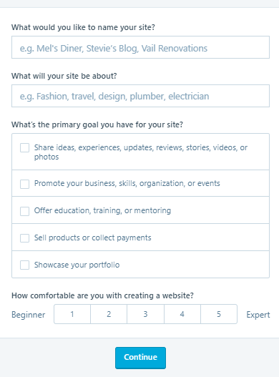

Our next step is to input our site name, what it will be about, your primary goal and how comfortable you are creating a website.

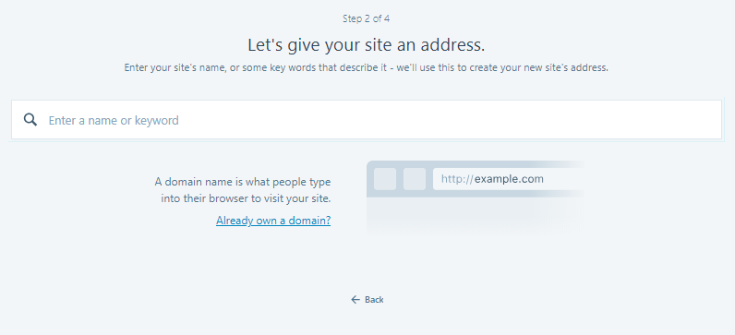

Enter the site name you would like, e.g if I wanted [www.Dylanm238273.com](http://www.Dylanm238273.com), type in Dylanm238273. This will give you many options for our domain name.

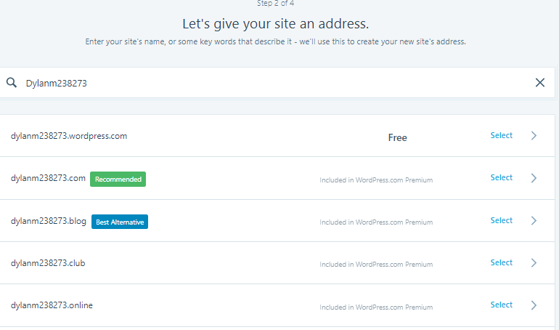

For free users, only the top option is available. If you are getting a premium account or better, you can pick your domain from the list.

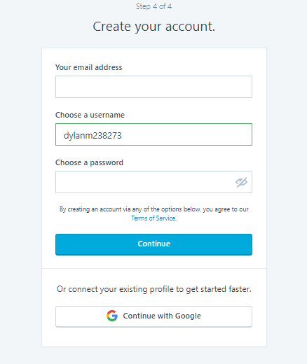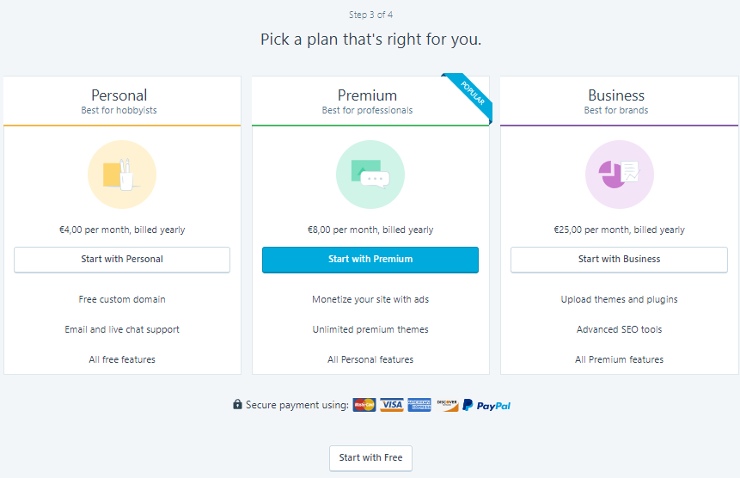

You can now enter your WordPress account password. You should make sure your details are only known to you and that no unauthorised users will be able to know your details.

You can now pick your price plan. The more you pay for your plan, the more benefits you will receive.

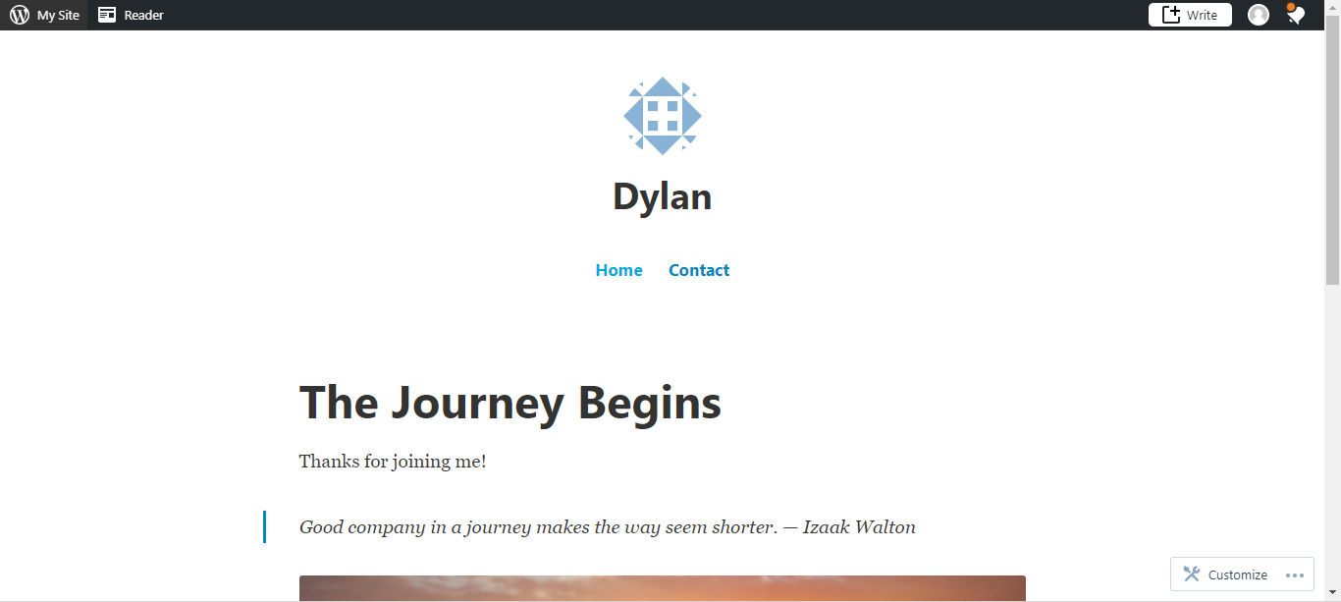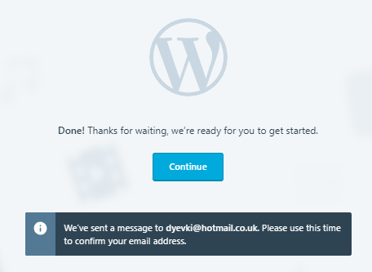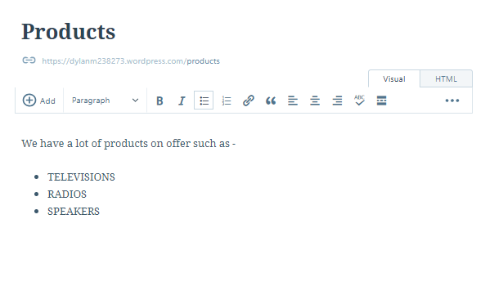

Now enter your email and confirm your email address and your website will be set up!

**Creating a page -**



Our first stop is to click “My site”. This is in the top left corner of the main website page.

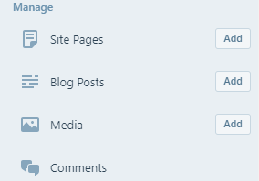

From there we will click “Add” beside what you would like to add. For this example, I am going to add a site page.

Websites content

URL

Title name

This will open a text input screen. Whatever you write in this will be displayed on the website.

A close up of a logo

Description generated with high confidence

Click publish in the top right and it will save to your website.

A screenshot of a cell phone

Description generated with very high confidence

That’s how you create a WordPress website and add a site page.